Building the CactusCon 2019 badge

Your kit includes the main PCB “Printed Circuit Board”, two sub-module sensor boards, a microcontroller with a color display, battery, lanyard and a couple smaller parts (very small). There are a handful of optional components available first-come, first served if you can complete your build including all of the standard components.

This year’s badge has both “through-hole” components and “SMD” components. SMD = Surface Mounted Devices. These are the defacto standard in most electronic devices made in the past decade. Often our electronics today are built by robotics and miniaturized in size. SMD parts are often the size of a grain of rice or even much smaller. You may notice the Microcontroller and sensor boards are made 100% of SMD parts. Only the connections to the main board are “through-hole”. The good news is you don’t need to install the SMD parts included with your badge unless you want to support optional parts. The options that require SMD are the LED “Light Emitting Diode” near the “eye” of your badge, and the optional gas sensor. Our gas sensor connection is modular and supports all sorts of gases, but for fun, we have limited supplies which can sense alcohol. (drinking while soldering, walking, driving or coding not recommended… Ok maybe while coding if along with a designated safe coder 😉)

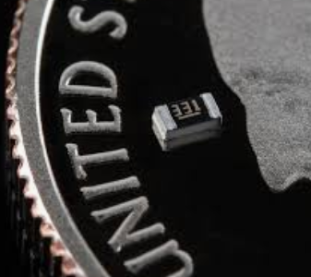 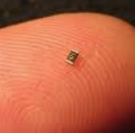 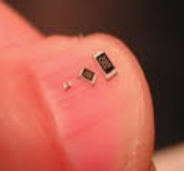

A) If you want to support the optional components, it’s a good idea to **begin with the SMD parts** as they are quite small and the mounting locations easiest to access while nothing else is installed. You can certainly still install the SMD parts later if you wish to wait.

The SMD parts are a resistor, two diodes and later the optional LED.

Start with the resistor. The location is just below the cutout in the middle and just above the “HEART-RATE” location.

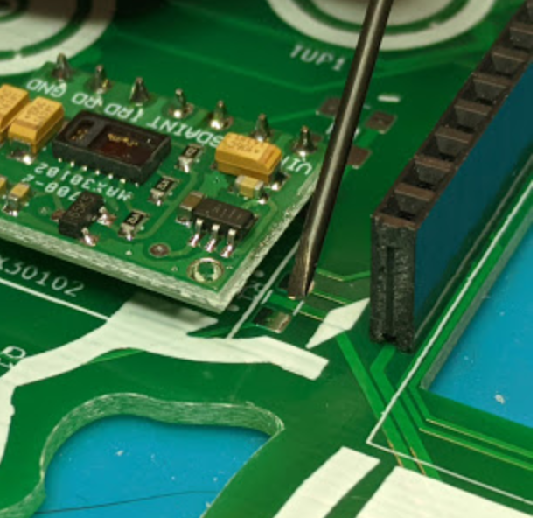

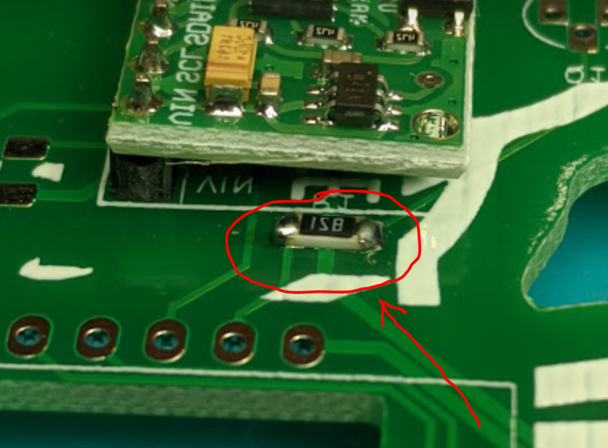

Using the soldering iron, add a tiny amount of solder to just one side to “wet” the connection. With the resistor in the tweezers in one hand, apply heat with the soldering iron to one pad and place the resistor on the wet pad. Remove the soldering iron, then when set, remove your tweezers.

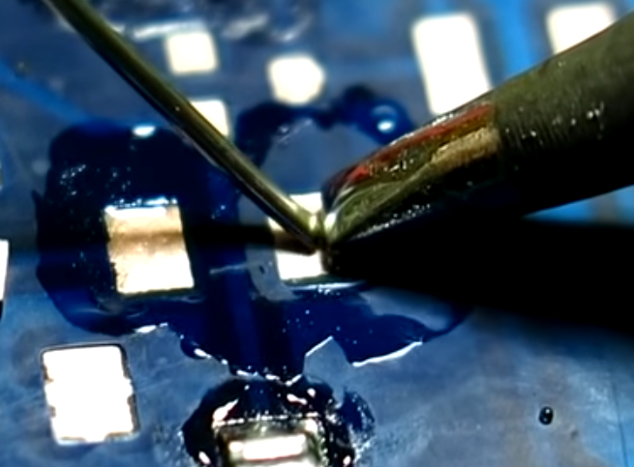 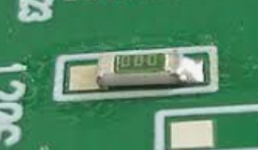

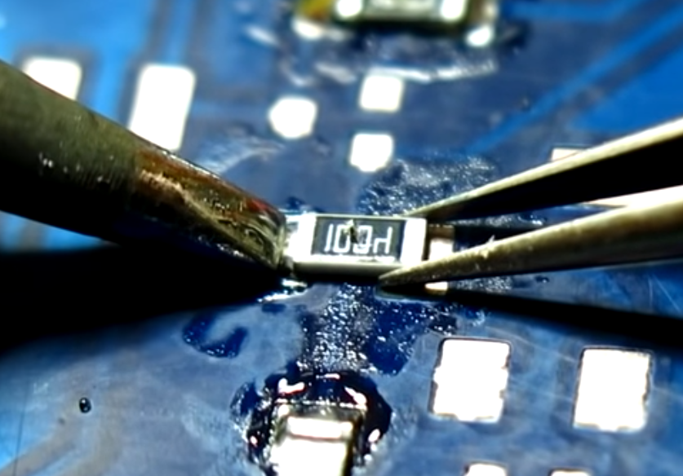

There’s a YouTube video for everything. We can demo for you here, or if trying this at home: <https://www.youtube.com/watch?v=_DsCdOaRUPM>

Now you can just apply solder to the other side to complete the connections.

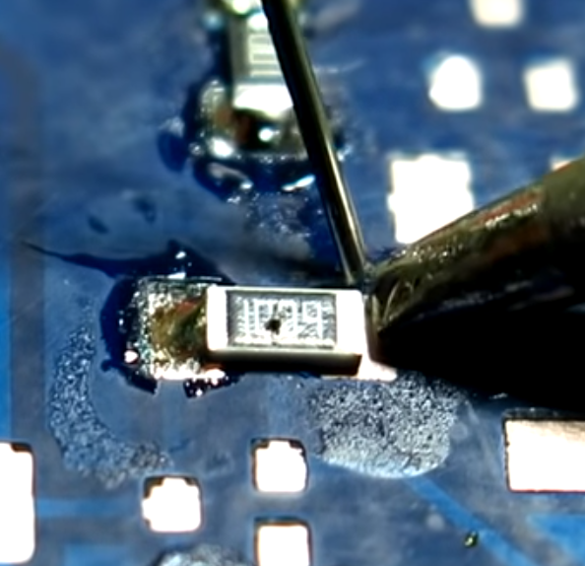

B) There are **two diodes** and they have a stripe to indicate the direction they must be mounted. A Diode is a device that only allows electricity to flow in one direction, but they also have a feature of dropping about 7 tenths of a volt when current flows. We needed about 1.4 volts of drop so we’re taking advantage of this to reduce the voltage to the LED. Two diodes are placed in series to add the voltage drop. The stripe should be facing the up side of the board. Our diodes are a bit bigger than we planned so this will be a greater challenge. Please don’t worry about this part. The LED at the “eye” is an extreme challenge for the experts here. Skip this step for now if you’re not up to it. The installation is just like the resistor in the previous step.

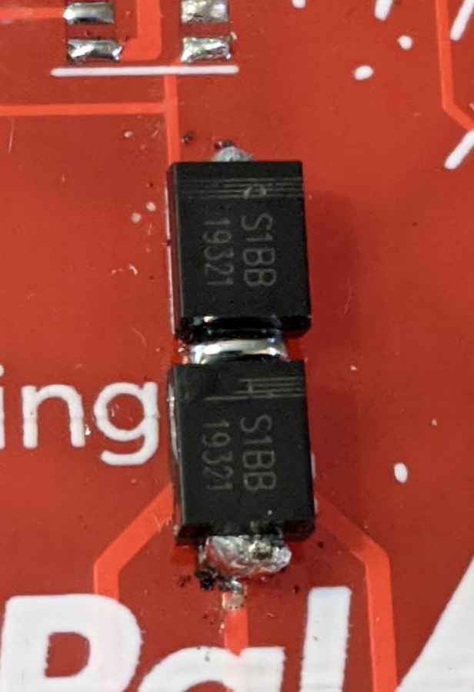

C) Now let’s begin installing **headers on the sensor module boards** and microcontroller.

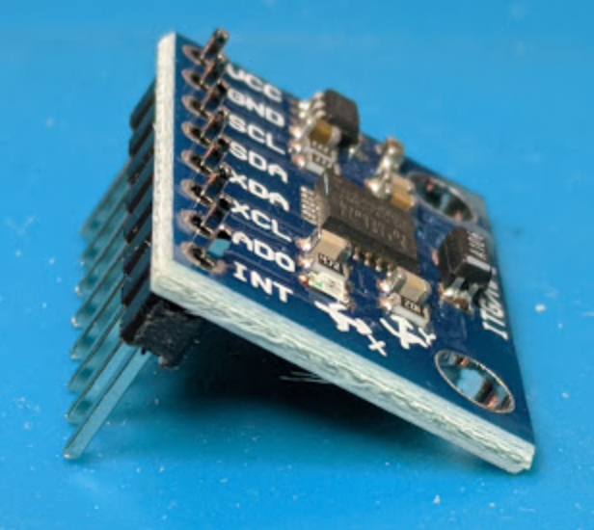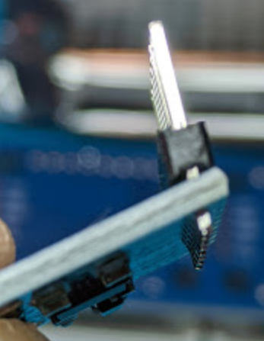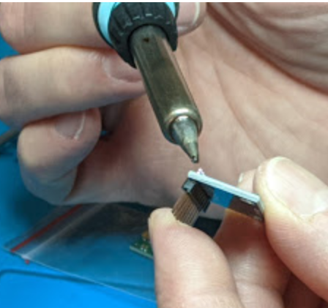

You can solder only one pin while holding the board and header. If the header is not mounted at a 90 degree angle, it’s very easy at this point to reheat the single pin and adjust until it’s square.

You may want to install the board to the main badge PCB with only one or two pins until you are confident the mounting is square.

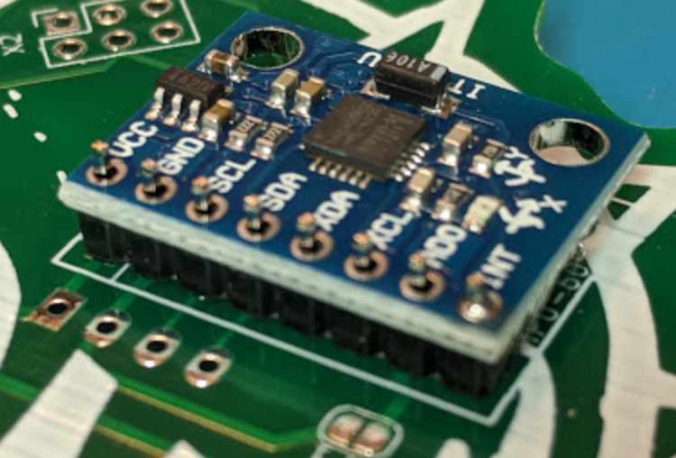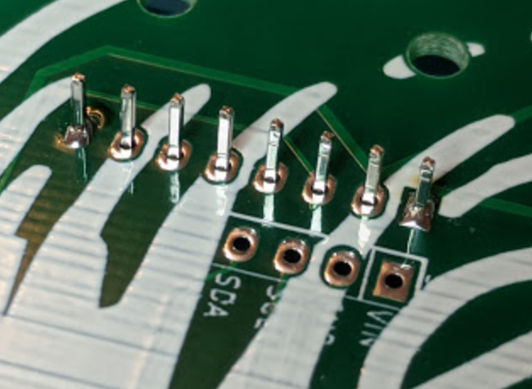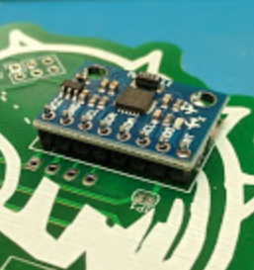

D) Here’s a trick you will want to try for the Microcontroller and socket. Try **building a stack** as shown here to ensure the pins are mounted at a perfect 90 degree angle before soldering.

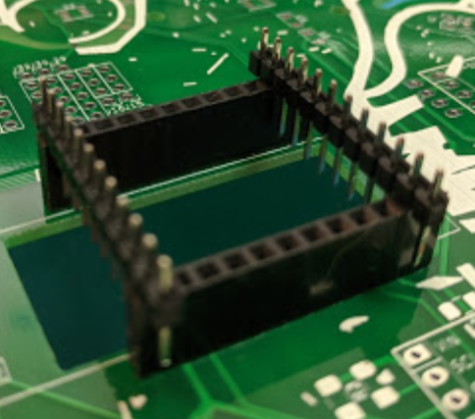

You can then flip the board over and solder just a couple pins to the main badge PCB now.

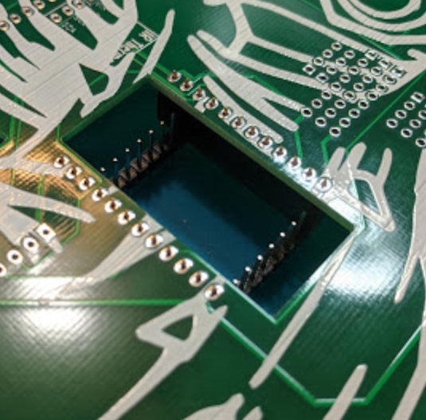

E) Afterwards, you can **place the pins into the Microcontroller board**, place them diagonally as shown and solder just a couple pins into the Microcontroller.

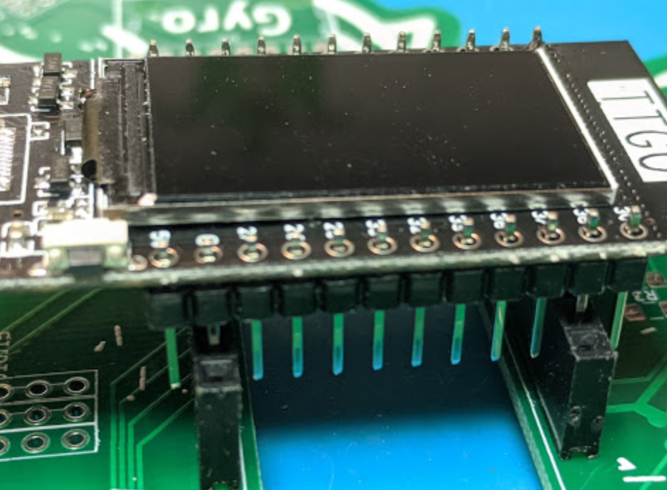

If all of your boards are squared up and mounting started and you are comfortable soldering, you can solder up both sides of all your connections and trim off the excess length of the pins. **Please be extra careful to cup or capture the flying ends as you clip**. Your eyesight and those around you are pretty important. Safety glasses should be worn by everyone in the area and you should be careful!

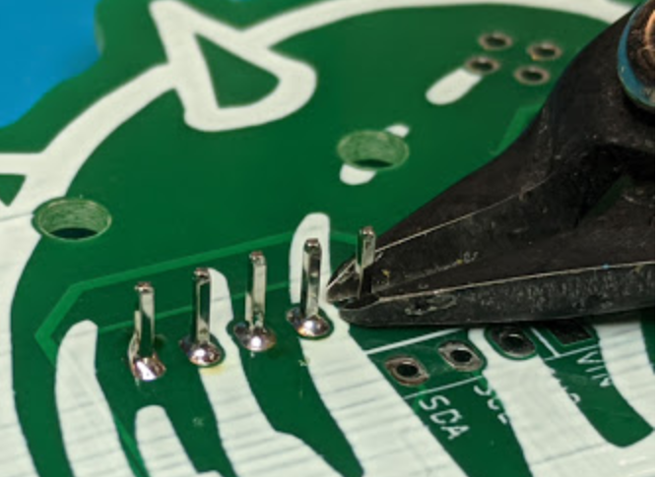 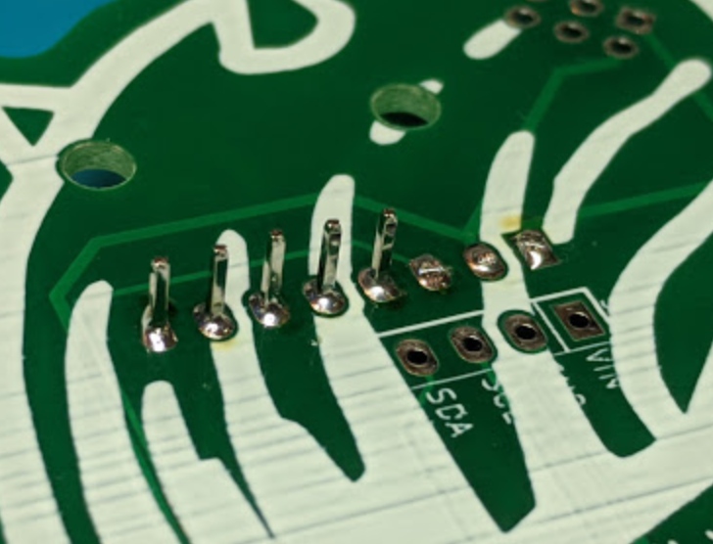

F) Congratulations. You can plug in a USB cable and **install the software** and you have a working badge.

G) **Plugin your battery** and mount it with foam tape or check out thingiverse and 3d print a holder for that battery. <https://www.thingiverse.com/thing:4081030> “CactusCon2019 Battery Holder”.

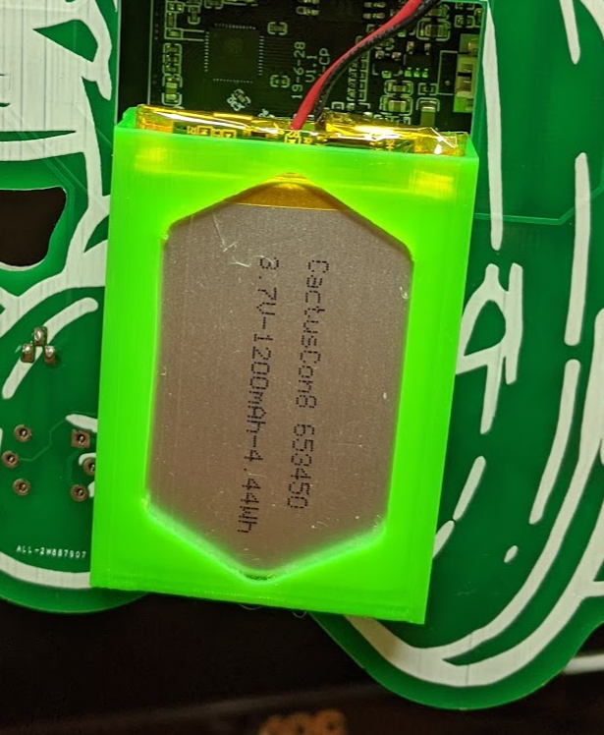

The End… Or is it?

H) If you want more of a challenge, you can **install the 2N2222 transistor**. A transistor is one the greatest inventions of the last 100 years. It’s responsible for the miniaturization of technology today and the 2N2222 has got to be the most popular transistor of all time. Transistors are used as switches and amplifiers. They work like a diode in that current only flows in one direction, but then can be switched on and off with just a tiny input signal. Our gas sensor has a heater inside of it and that can drain your battery quickly and it’s more power than our tiny microcontroller and deliver on its own. But our mighty 2N2222 can handle it. The silk-screen on your PCB shows you the proper orientation of the transistor which has a flat side on it so we can tell which lead is which. Take a look at the photo and solder than little guy in as shown.

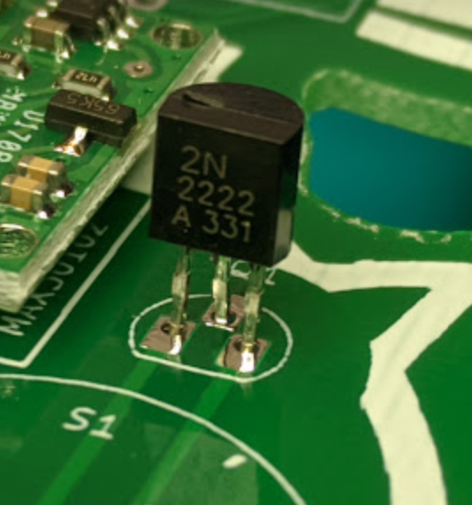

I) If you have made it this far, **you deserve a drink** 😉… *Drinks not included*… but first, check in, show off your work and see if we have alcohol sensors available as a reward. You can Google, Alta-Vista, Lycos, AskJeeves, Excite, Hotbot, DuckDuck or Bing for the “MQ-3 gas sensor” to learn more about how the sensors work or where to buy one if we’re run out. Heck, maybe you’re interested in the MQ-2 or the MQ-4 or the MQ-309, don’t stop there. How many can you find?

You can mount that sensor either way it fits.

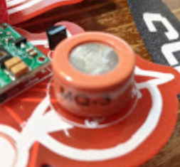

J) OK, we have another treat for you. Have you been to defcon? **We’ve added an SOA “Shitty Add-On”** interface allowing you to connect accessories from DefCon™ #BadgeLife℠ badges. If you want one, you can have one while supplies last or ask for a second one if you have brought any other badges to show off or talk about.

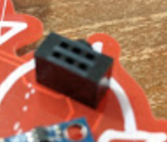 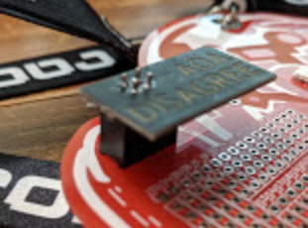

K) And finally, the challenge of challenges, can you **mount the SMD LED** which is not quite a perfect fit, with a very temperature sensitive component with no visible pads after setting the LED in place?

Show us you’ve made it this far and we’ll let you give a try once. Succeed and you might get a second LED if we have supplies.

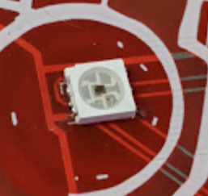 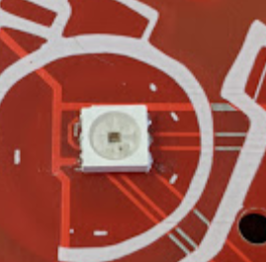

**Thank you so much for being here and making it this far**. See you in 2021! We’re already started working on something really cool for next time.